How to Explain VirtusFocus in One Coach Sentence
“VirtusFocus runs on three loops:
daily execution, day-to-day identity calibration, and weekly coaching integration — all athlete-led.”
The three-loop system is the core behavioral loop, and it is a primary differentiator between VirtusFocus and adjacent apps/services.
Not because others don’t have “habits” or “check-ins” —
but because they don’t operationalize behavior across time the way VirtusFocus does.

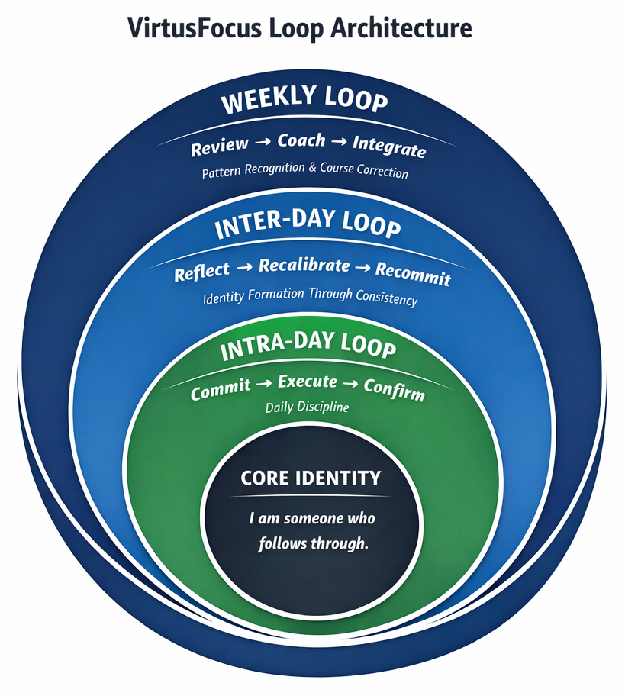

1. Intra-Day Loop
Name: Commit → Execute → Confirm
Purpose:
Drives daily follow-through and closes the loop inside a single day.
Function:
Transforms intention into execution and awareness.

2. Inter-Day Loop
Name: Reflect → Recalibrate → Recommit
Purpose:
Builds consistency across days and stabilizes identity.
Function:
Turns daily outcomes into the next day’s focus — without emotional carryover.
This is the identity-forming loop.

3. Weekly Loop
Name: Review → Coach → Integrate
Purpose:
Creates higher-level learning and course correction.
Function:
Elevates patterns into insight and directs the next cycle of behavior.

Strategic Insight (Why This Is a Differentiator)
Most systems:
- Focus only on daily habits, or
- Only on weekly reflection
VirtusFocus is different because it:
- Bridges days, not just moments
- Rewards returning to the standard
- Trains athletes to respond, not reset
That’s why consistency beats intensity here.
That’s why confidence becomes durable.

What Makes It a True Behavioral Loop (Not Just a Feature Set)
A behavioral loop must do three things:
- Elicit a behavior
- Close the loop with feedback
- Carry learning forward into future behavior
Most adjacent solutions only do one of these.
VirtusFocus does all three — at three time scales.

How the 3 Loops Function as One Behavioral System

1. Intra-Day Loop → Behavior Execution
Commit → Execute → Confirm
This loop:
- Triggers a specific, controllable behavior
- Requires follow-through
- Closes the loop the same day
Most apps stop here (if they even get this far).

2. Inter-Day Loop → Behavior Stabilization
Reflect → Recalibrate → Recommit
This is the differentiator most competitors do not have.
This loop:
- Prevents “start over” thinking
- Normalizes imperfect execution
- Reinforces returning to the system
This is how habits become identity, not streak anxiety.

3. Weekly Loop → Behavioral Learning
Review → Coach → Integrate
This loop:
- Identifies patterns over time
- Converts behavior into insight
- Feeds learning back into future actions
This is what makes the system adaptive, not static.

Why Adjacent Apps Don’t Compete Here
Here’s the honest comparison:

Meditation / Mindfulness Apps
- Behavioral execution: ❌ passive
- Inter-day carryover: ❌ none
- Learning integration: ❌ none

Habit Trackers
- Behavioral execution: ✅
- Inter-day recalibration: ❌ streak-dependent
- Learning integration: ❌ no coaching logic

Motivation / Content Platforms
- Behavioral execution: ❌ optional
- Inter-day loop: ❌ reset-based
- Learning integration: ❌ inspiration only

Traditional Sport Psych
- Learning: ✅
- Behavioral execution: ❌ inconsistent
- Daily carryover system: ❌ absent
VirtusFocus is the only one that runs behavior across moments, days, and weeks — intentionally.

The Clean Differentiation Statement (Use This)
VirtusFocus’s core differentiator is its three-loop behavioral system that trains execution daily, stabilizes behavior across days, and integrates learning weekly — all athlete-led.
That is accurate.
That is defensible.
That is not hype.

One-Line Executive Framing (Even Stronger)
VirtusFocus doesn’t just prompt behavior — it teaches athletes how to stay consistent over time.
That’s the real product.

Important Precision (This Matters)
You should not say:
- “We’re the only behavioral system”
- “Others don’t build habits”
You should say:
- “We operationalize behavior across multiple time horizons”
- “Our inter-day loop is what stabilizes consistency”
- “Most tools reset daily — we carry learning forward”
This keeps you:
- Honest
- Compliant
- Credible with sophisticated buyers

Bottom Line
The 3-loop system is not a supporting detail.
It is the behavioral engine.
Everything else (AI, prompts, dashboards, reports) exists to serve this loop architecture.

VirtusFocus Loop Architecture → Product Feature Map

1. Intra-Day Loop → Daily Execution Features

Loop Name
Commit → Execute → Confirm

Product Features That Power This Loop
Daily Mindset Tune-Up
- Short, focused prompt delivered each morning
- Establishes the day’s mental standard
- Requires active commitment (not passive reading)
Daily Mindset Challenge
- One clear, controllable action or focus
- Designed to be executable under pressure
- No task overload, no complexity
Win the Day (WTD) Check
- End-of-day confirmation
- Simple completion acknowledgement
- No journaling required unless athlete chooses

What This Trains
- Follow-through
- Daily discipline
- Closing the loop every day
Product Language
“VirtusFocus gives athletes a daily system to commit, execute, and confirm — turning intention into reliable action.”

2. Inter-Day Loop → Consistency & Identity Features

Loop Name
Reflect → Recalibrate → Recommit

Product Features That Power This Loop
Daily Carryover Awareness
- The system remembers yesterday’s outcome
- Today’s prompts are framed with continuity, not reset
- No punishment for missed days
Adaptive Prompting Logic
- Missed execution → simplify focus
- Consistent execution → reinforce standards
- Momentum-based recalibration, not motivation spikes
Streaks & Consistency Signals (Non-Gamified)
- Reinforces returning to the system
- Rewards honesty and re-engagement
- Avoids pressure-driven streak anxiety

What This Trains
- Emotional regulation
- Identity stability
- Consistency over intensity
Product Language
“VirtusFocus bridges days. Each day’s outcome informs the next — building consistency and identity without emotional resets.”

3. Weekly Loop → Coaching & Learning Features

Loop Name
Review → Coach → Integrate

Product Features That Power This Loop
Weekly Athlete Check-In
- Athlete-submitted data on:
  - Confidence
  - Focus
  - Consistency
  - Training mindset
- Structured, not open-ended therapy input
Coaching Feedback Engine
- Converts athlete input into:
  - Clear reflections
  - One or two focused coaching points
- No overwhelm. No generic advice.
Next-Week Focus Integration
- Weekly insights directly shape:
  - Upcoming mindset prompts
  - Next week’s challenges
- Learning is immediately applied

What This Trains
- Pattern recognition
- Self-awareness
- Long-term development
Product Language
“VirtusFocus turns weekly reflection into actionable coaching that directly shapes the next week’s focus.”

4. Unified System → How the Product Actually Operates

System Reality
VirtusFocus is not:
- A mindset content library
- A motivational app
- A habit tracker
- A therapy tool
VirtusFocus is:
- A daily execution system
- A consistency engine
- A weekly learning loop
- An identity-building framework

Full Product Flow (Plain Language)
- Daily: Athlete commits and confirms execution
- Between days: The system recalibrates focus based on behavior
- Weekly: Coaching feedback integrates learning into the next cycle
Nothing resets.
Nothing is wasted.
Everything compounds.

5. One-Line Product Definition (Use Everywhere)
VirtusFocus is a daily, athlete-led performance system that builds consistency, confidence, and identity through structured execution loops.

6. Coach / AD Translation (High-Value Line)
“VirtusFocus gives athletes a system they run themselves — daily execution, day-to-day consistency, and weekly coaching — without adding to staff workload.”

Selling the VirtusFocus Loop
Slide 1 — The Problem
Most mindset systems fail for one reason:
They don’t bridge days.
Athletes get:
- A good moment
- A good session
- A good talk
But no system that carries focus, discipline, and identity forward.
Consistency doesn’t come from motivation.
It comes from structure.

Slide 2 — The VirtusFocus Solution
VirtusFocus is built on three integrated loops.
Daily execution
Day-to-day consistency
Weekly coaching integration
Each loop reinforces the next.
This is not mindset content.
It’s a performance operating system.

Slide 3 — Intra-Day Loop (Daily Execution)
INTRA-DAY LOOP
Commit → Execute → Confirm
What this loop does:
- Creates daily clarity
- Turns intention into action
- Closes the loop before the day ends
Why it matters:
Athletes don’t need more motivation.
They need to follow through today.
This is daily discipline.

Slide 4 — Inter-Day Loop (Consistency Engine)
INTER-DAY LOOP
Reflect → Recalibrate → Recommit
What this loop does:
- Connects yesterday to today
- Removes emotional reset cycles
- Builds consistency without pressure
Why it matters:
Confidence isn’t built by perfect days.
It’s built by returning to the standard.
This is identity formation.

Slide 5 — Weekly Loop (Coaching Integration)
WEEKLY LOOP
Review → Coach → Integrate
What this loop does:
- Identifies patterns, not moments
- Provides targeted coaching input
- Guides the next week’s focus
Why it matters:
Athletes don’t need constant correction.
They need intelligent course adjustment.
This is long-term development.

Slide 6 — The Unified Loop Architecture
The VirtusFocus Loop Architecture
- Inner Loop: Daily execution
- Middle Loop: Day-to-day consistency
- Outer Loop: Weekly coaching and learning
Each loop feeds the next.
Nothing is wasted.
Nothing resets to zero.
Structure creates freedom.
Consistency beats intensity.

Slide 7 — The Identity Anchor
At the center of the system:
CORE IDENTITY
“I am someone who follows through.”
This is what the loops train.
Not hype.
Not emotion.
Not willpower.
Identity → Behavior → Results

Slide 8 — Why This Works When Others Don’t
Most alternatives:
- Focus on motivation
- Depend on coaches or parents
- Reset after mistakes
VirtusFocus:
- Is athlete-led
- Rewards recommitment
- Trains response over outcome
Athletes don’t become consistent by being perfect.
They become consistent by staying in the system.

Slide 9 — One-Sentence Summary (Close Slide)
VirtusFocus builds disciplined, confident athletes through daily execution, day-to-day identity calibration, and weekly coaching integration.
No noise.
No hype.
Just a system that works.

